1.

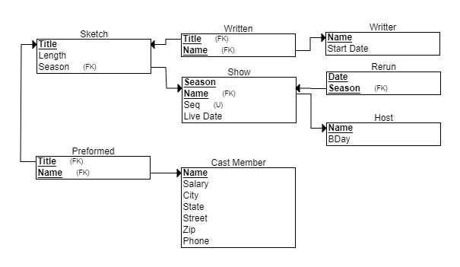

2.

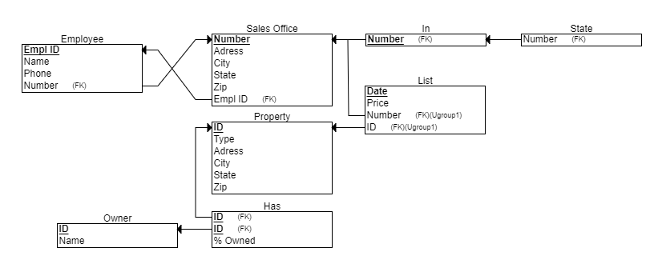

3.

1. The year column uses the last two digits so “2020” doesnt fit in.
2. The first section (the one specified) will be deleted, set to NULL
3. That entry already exists so it will be redundant.
4. The change will be made, if there are other section_identifiers with 85 then then they would also be changed.

Primary keys:

* Course(course_number) <- Section(course_number)
* Student(student_number) <- Grade_report(student_number)
* Section(section_identifier) <- Grade_report(section_identifier)
* Course(course_number) <- Prerequisite(course_number)